**25-09-2018** **END SEM LAB EXAM 1740256**

--------------------------------------------------------------------------------------------------------------------------------------

**QUESTION 1**

**Aim:**

*The following data relate to monthly income and expenditure under different heads for 2 families –*

|  |  |  |
| --- | --- | --- |
| **ITEM OF EXPENDITURE** | **FAMILY A (MONTHLY INCOME – RS. 12000)** | **FAMILY B (MONTHLY INCOME – RS. 16000)** |
| **Food** | **4000** | **4800** |
| **Clothing** | **2500** | **3000** |
| **Rent** | **3000** | **4000** |
| **Education** | **1500** | **2500** |
| **Fuel & Lighting** | **400** | **800** |
| **Others** | **600** | **900** |

*Show the above data by a suitable diagram and interpret the same.*

**Procedure:**

**> df<-data.frame(Item_of_expenditure=c("Food","Clothing","Rent","Education","Fuel and lighting","Others"),Family_A=c(4000,2500,3000,1500,400,600),Family_B=c(4800,3000,4000,2500,800,900))**

**> df**

**Item_of_expenditure Family_A Family_B**

**1 Food 4000 4800**

**2 Clothing 2500 3000**

**3 Rent 3000 4000**

**4 Education 1500 2500**

**5 Fuel and lighting 400 800**

**6 Others 600 900**

**> plot(df,main="MONTHLY INCOME AND EXPENDITURE FOR 2 FAMILIES",col="red")**

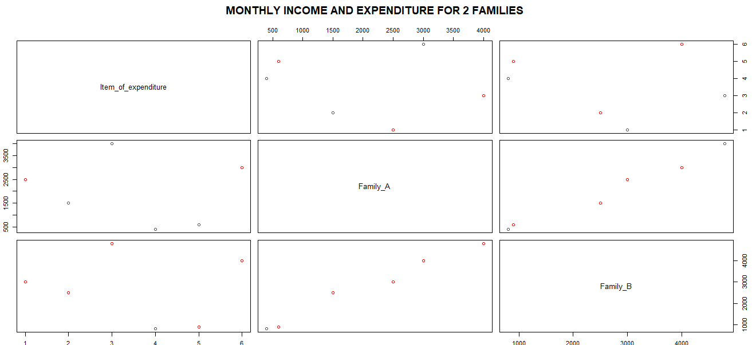

**Conclusion:**

From this diagram – we can observe the monthly income of 2 families and how they have divided it according to their items of expenditure. A data-frame has been created in R and then a plot has been created according to the table.

--------------------------------------------------------------------------------------------

**QUESTION 2**

**Aim:**

*The table below gives the data regarding industrial consumption index of electricity and industrial production index from 1995 to 2014.*

|  |  |  |
| --- | --- | --- |
| **Year** | **Electricity** | **Production** |
| **1995** | **36.6** | **54.8** |
| **1996** | **39.5** | **57.2** |
| **1997** | **42.4** | **58.1** |
| **1998** | **47.6** | **63.4** |
| **1999** | **53.4** | **72.5** |
| **2000** | **58.5** | **78.4** |
| **2001** | **66.1** | **82.7** |
| **2002** | **74.9** | **84.4** |
| **2003** | **87.1** | **90.3** |
| **2004** | **100** | **100** |
| **2005** | **115.1** | **109.2** |
| **2006** | **131.7** | **119.8** |
| **2007** | **150** | **129.7** |
| **2008** | **162.6** | **140.8** |
| **2009** | **176.3** | **153.8** |
| **2010** | **190.4** | **153.2** |
| **2011** | **209.4** | **152.6** |
| **2012** | **233.6** | **163** |
| **2013** | **255.7** | **175.3** |
| **2014** | **271.4** | **184.3** |

**Calculations:**

**> pro<-read_excel("Production.xlsx")**

**> pro**

**# A tibble: 20 x 3**

**Year Electricity Production**

**<dbl> <dbl> <dbl>**

**1 1995 36.6 54.8**

**2 1996 39.5 57.2**

**3 1997 42.4 58.1**

**4 1998 47.6 63.4**

**5 1999 53.4 72.5**

**6 2000 58.5 78.4**

**7 2001 66.1 82.7**

**8 2002 74.9 84.4**

**9 2003 87.1 90.3**

**10 2004 100 100**

**11 2005 115. 109.**

**12 2006 132. 120.**

**13 2007 150 130.**

**14 2008 163. 141.**

**15 2009 176. 154.**

**16 2010 190. 153.**

**17 2011 209. 153.**

**18 2012 234. 163**

**19 2013 256. 175.**

**20 2014 271. 184.**

**> cor(pro$Electricity,pro$Production)**

**[1] 0.9881168**

**> var(pro$Electricity)**

**[1] 5897.41**

**> var(pro$Production)**

**[1] 1820.654**

**> var(pro$Electricity,pro$Production)**

**[1] 3237.819**

**> c<-var(pro$Electricity,pro$Production)/sqrt(var(pro$Electricity)*var(pro$Production))**

**> c**

**[1] 0.9881168**

**> var.test(pro$Electricity,pro$Production)**

**F test to compare two variances**

**data: pro$Electricity and pro$Production**

**F = 3.2392, num df = 19, denom df = 19, p-value = 0.01384**

**alternative hypothesis: true ratio of variances is not equal to 1**

**95 percent confidence interval:**

**1.282104 8.183609**

**sample estimates:**

**ratio of variances**

**3.239172**

**> qt(0.05,19)**

**[1] -1.729133**

**Conclusions:**

In the above calculations –

* An excel sheet called **Productions** has been imported into R.
* The correlation coefficient between industrial consumption index of electricity and industrial production index has been calculated and the value is 0.9881168. To cross check the value – another formula has also been used to calculate the correlation coefficient and that is using the product of the variances with the square root and that value has also turned out to be 0.9881168.
* The significance has been tested using the F test as the variances of the industrial consumption index of electricity and industrial production index has been compared.
* As we can see in the output – the p value is lesser than the alpha value which is 0.05 and therefore we reject the null hypothesis and accept the alternate hypothesis where-in the true ratio of variances are not equal to 1 at 5% level of significance.

--------------------------------------------------------------------------------------------

**QUESTION 3**

**Aim:**

*Following figures give the rice yield of ten randomly selected plots. On the basis of the following data test that the average yield of rice is 30 q/ha.*

**FORAGE YIELD(q/ha): 21.8, 24.8, 27.3, 29.3, 30.8,31.8, 32.4,32.5, 32.1, 31.3.**

**Procedure:**

**> t.test(forage,mu=30)**

**One Sample t-test**

**data: forage**

**t = -0.50975, df = 9, p-value = 0.6225**

**alternative hypothesis: true mean is not equal to 30**

**95 percent confidence interval:**

**26.7917 32.0283**

**sample estimates:**

**mean of x**

**29.41**

**> qt(0.05,9)**

**[1] -1.833113**

**Conclusion:**

**In the above calculations – we see that the t test is used for single mean to test the average yield of rice as 30 q/ha. Since the p – value which is 0.6225 is greater than 0.05, we accept the null hypothesis and reject the alternate hypothesis and can conclude that the true mean is equal to 30.**

**Null Hypothesis:** True mean is equal to 30. There is no significant difference between the true mean and calculated mean.

**Alternate Hypothesis:** True mean is not equal to 30. There is a significant difference between the calculated mean and true mean. --------------------------------------------------------------------------------------------